INSTITUTO TECNOLÓGICO SUPERIOR DE CD CONSTITUCIÓN
4to Trimestre del Ejercicio 2023

Ubicación de la información:
http://cdconstitucion.tecnm.mx/somoshalcones/index.html

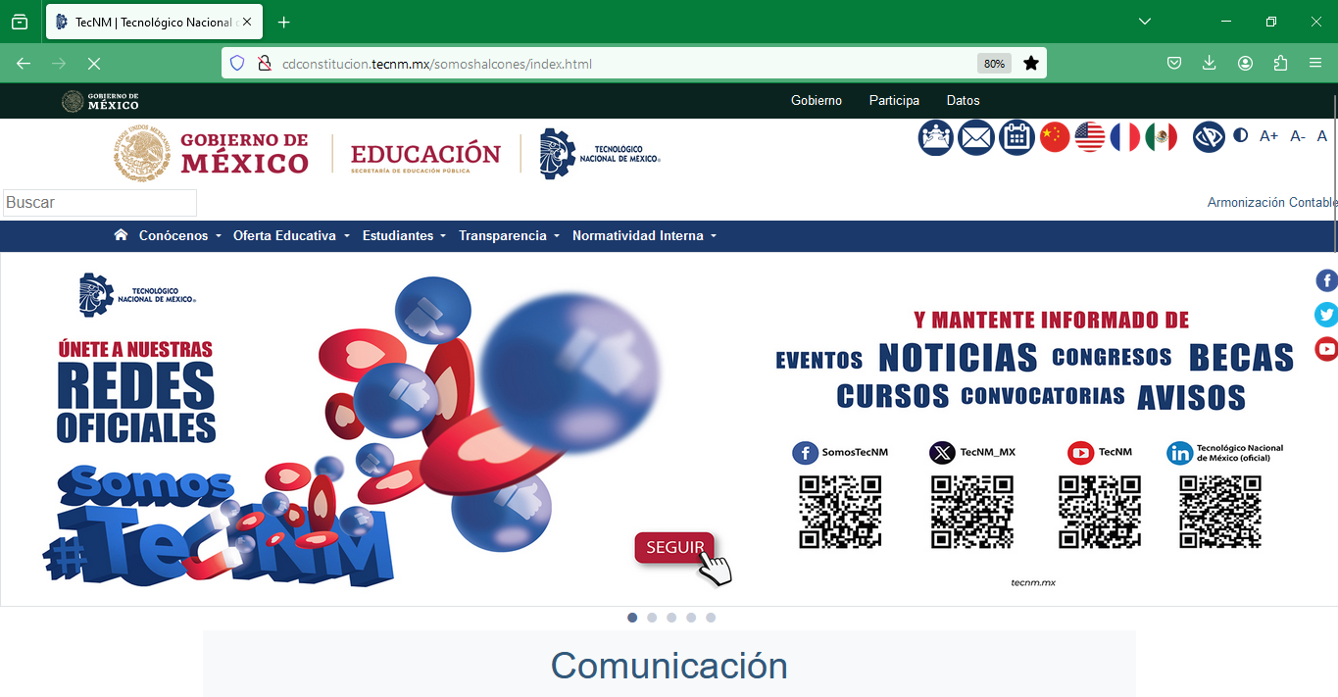

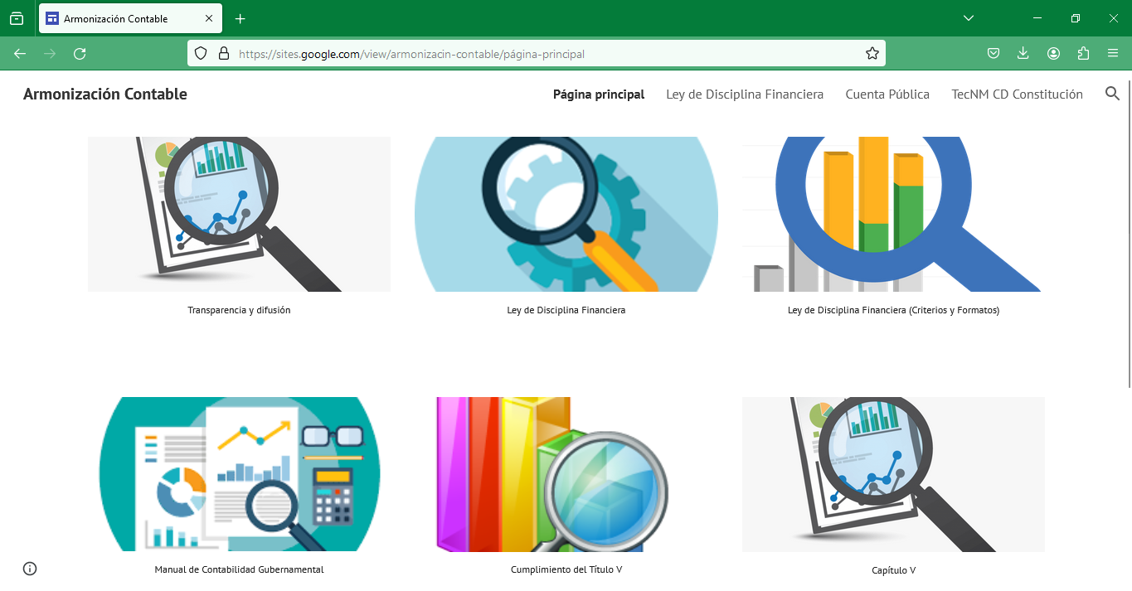

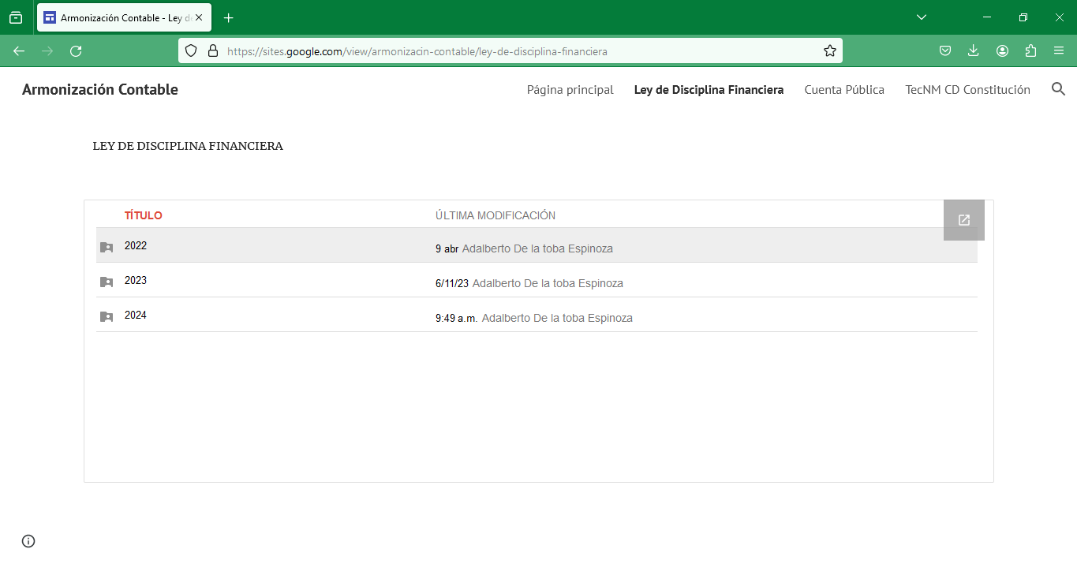

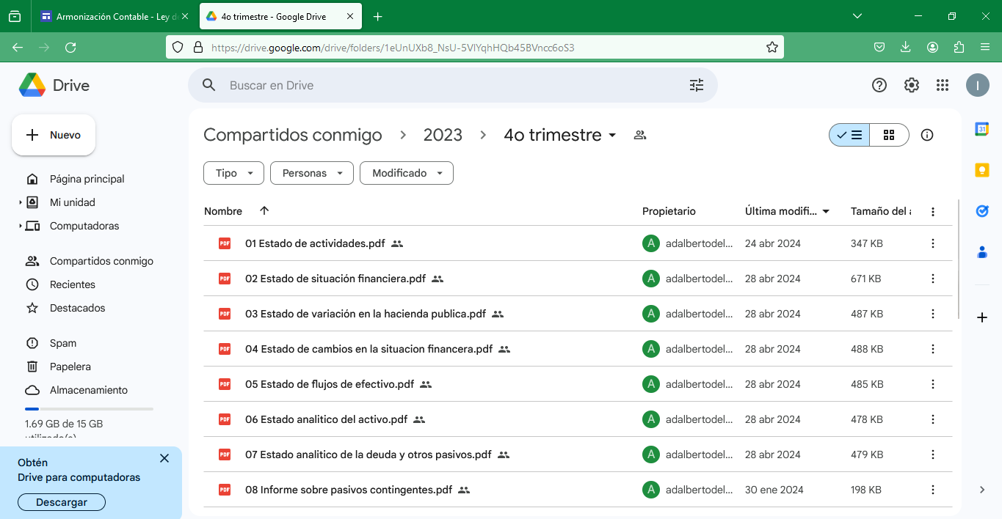

1.
https://drive.google.com/drive/folders/1eUnUXb8_NsU-5VlYqhHQb45BVncc6oS3
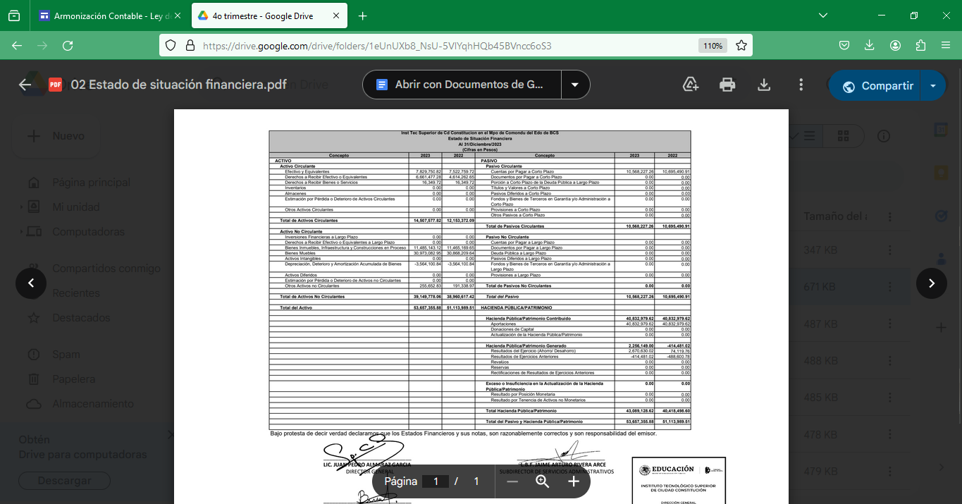

2.
https://drive.google.com/drive/folders/1eUnUXb8_NsU-5VlYqhHQb45BVncc6oS3

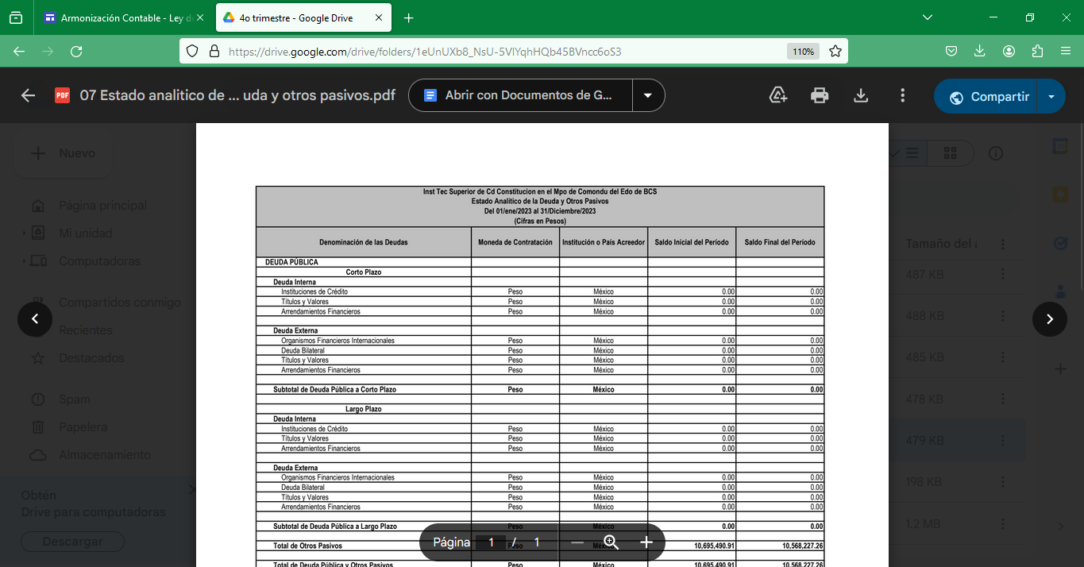

3.
https://drive.google.com/drive/folders/1eUnUXb8_NsU-5VlYqhHQb45BVncc6oS3
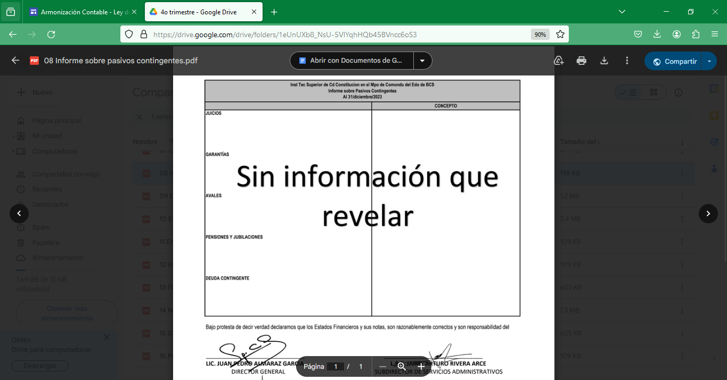
4.
https://drive.google.com/drive/folders/1eUnUXb8_NsU-5VlYqhHQb45BVncc6oS3
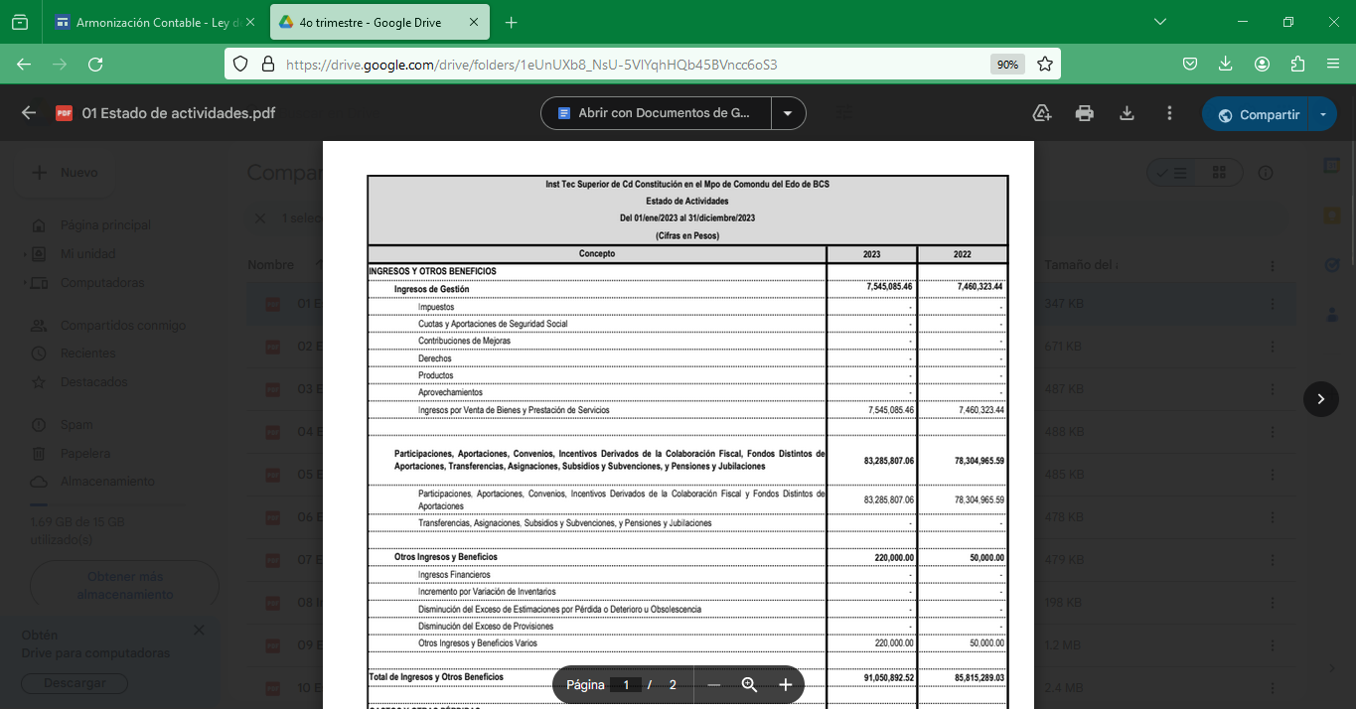

5.
https://drive.google.com/drive/folders/1eUnUXb8_NsU-5VlYqhHQb45BVncc6oS3
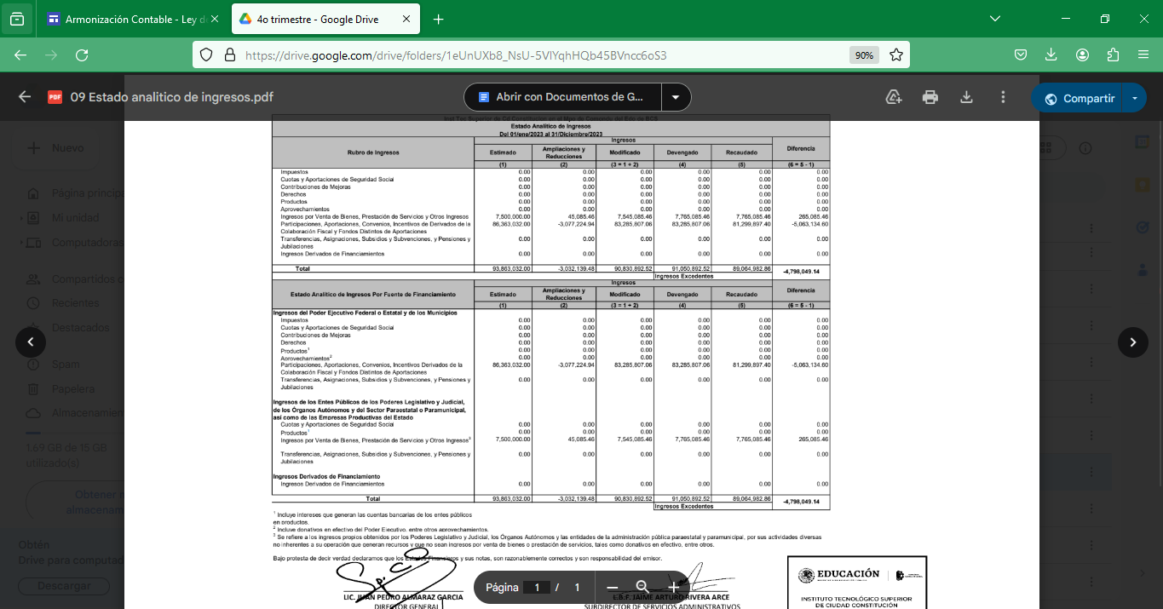

6.
https://drive.google.com/drive/folders/1eUnUXb8_NsU-5VlYqhHQb45BVncc6oS3
